## COLLEGE OF ENGINEERING AND MANAGEMENT ,KOLAGHAT

NAME: SANTU JANA  
UNIVERSITY ROLL: 10700121127  
COLLEGE ROLL:CSE/21/L-146  
TITLE OF THE REPORT: **Knowledge Representation**

## -: CONTENTS:-

## 1.INTRODUCTION 2.OBJECTIVE 3.GOAL 4.DISCUSSION WITH DIAGRAMS/TABLES 5.CONCLUSION

## 6.RECOMMEDATION 7 .REFERENCE

## Introduction

Artificial Intelligence as technology has always fascinated human beings. There have been multiple science fiction novels and movies where AI-powered systems such as Robots can think, act, understand complex information, and make smart decisions based on it. However, one concept that one must understand before creating that level of Artificial Intelligence is rather psychological or biological. What makes humans different from other animals or machines is our conscience. While scientists have often found it difficult to explain what conscience is, one can agree that it is the sum of our memories, i.e., all the knowledge we have gathered so far. This knowledge makes different personalities and makes humans behave differently and take different actions. Therefore, all the capabilities of humans stem from this gathered knowledge. Thus, prior knowledge of knowing that a teacup is hot refrains us from touching it. If we were to make AI more sophisticated, we would be required to provide them with more and often complex information about our world to perform the complex task, which leads to the concept of Knowledge Representation in Artificial Intelligence.

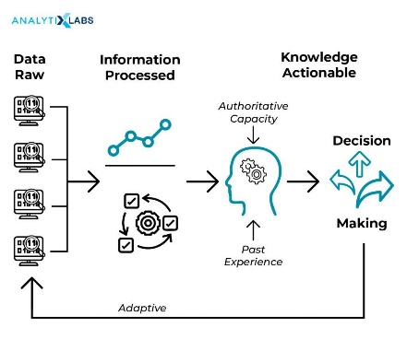

***Objective***

Numerous objects constantly surround humans. The information regarding these objects is something that we can consider as a type of knowledge. For example, cars have wheels, and the piano has keys, the train is a locomotive, etc.

***GOAL***

The Goal of **Knowledge Representation**

We believe that the driving preoccupation of the field of knowledge representation should be understanding and describing the richness of the world. Yet in practice research that describes itself as core knowledge representation work has concentrated nearly all of its efforts in a much narrower channel, much of it centered around taxonomic and default reasoning (e.g., [2], [15], [8]).

We believe it is not an accident that useful insight about finding a good set of temporal abstractions came from close examination of a realistic task set in a real-world domain. It underscores our conviction (shared by others; see [14]) that attempting to describe the richness of the natural world is the appropriate forcing function for KR work

Our point here concerns both labeling and methodology: (i) work like [10] and [14] should be recognized by the KR community as of central relevance to KR research, not categorized as diagnosis or qualitative physics and seen as unrelated, and (ii) insights of the sort obtained in [10] and [14] come from studying the world, not from studying languages. We argue that those who choose to identify themselves as KR researchers should be developing theory and technology that facilitates projects like these; and conversely those who are building projects like these are engaged in a centrally important variety of KR research.

While tools and techniques are important, the field is and ought to be much richer than that, primarily because the world is much richer than that. We believe that understanding and describing that richness should be the central preoccupation of the field.

***DISCUSSION WITH DIAGRAMS/TABLE***

**Types of Knowledge Representation**

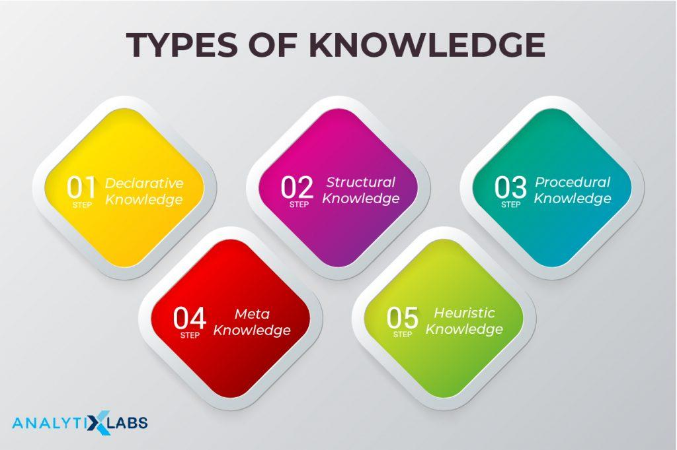

Given the understanding of the complexity of knowledge representation in AI, one thing is pretty obvious: to represent knowledge to machines, we first have to identify and classify the different types of knowledge. While above we have done so to a certain degree, the following are the formal terms and definitions in which the knowledge can represent-

* **Declarative Knowledge**:It is the knowledge that represents the facts, objects, concepts that help us describe the world around us. Thus it deals with the description of something.
* **Procedural Knowledge**:This type of knowledge is more complex than declarative knowledge as it refers to a more complex idea, i.e., how things behave and work. Thus this knowledge is used to accomplish any task using certain procedures, rules, and strategies, making the system using this knowledge work efficiently. Also, this type of knowledge highly depends on the task we are trying to accomplish.
* **Meta KnowledgE:** As mentioned earlier, meta-knowledge is the group of knowledge that is a type of knowledge when combined. Thus, it is the knowledge regarding other types of knowledge.
* **Heuristic Knowledge**: The knowledge provided by experts of certain domains, subjects, disciplines, and fields is known as the Heuristic knowledge, which they have been obtained after years of experience. This type of knowledge helps in taking the best approach to particular problems and making decisions.
* **Structural Knowledge**

This type of knowledge helps establish relationships between concepts or objects and their description, acting as the basic form of knowledge to solve real-world problems.

**Properties of Knowledge Representation**

Whenever knowledge representation in AI is discussed, we discuss creating the knowledge representation system that can represent the various types of knowledge discussed above. This system must manifest certain properties that can help us in assessing the system. Following are these properties-

* **Representational Adequacy**

A major property of a knowledge representation system is that it is adequate and can make an AI system understand, i.e., represent all the knowledge required by it to deal with a particular field or domain.

* **Inferential Adequacy**

The knowledge representation system is flexible enough to deal with the present knowledge to make way for newly possessed knowledge.

* **Inferential Efficiency**

The representation system cannot accommodate new knowledge in the presence of the old knowledge, but it can add this knowledge efficiently and in a seamless manner.

* **Acquisitional Efficiency**

The final property of the knowledge representation system will be its ability to gain new knowledge automatically, helping the AI to add to its current knowledge and consequently become increasingly smarter and productive.

**Use of Knowledge Representation in the AI Knowledge Cycle**

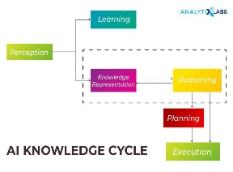

Our main aim when building an AI system to come up with a knowledge representation system that will help us feed in the knowledge. This knowledge representation will be used in AI in the following ways-

* **Perception Block**

This will help the AI system gain information regarding its surroundings through various sensors, thus making the AI system familiar with its environment and helping it interact with it. These senses can be in the form of typical structured data or other forms such as video, audio, text, time, temperature, or any other sensor-based input.

* **Learning Block**

The knowledge gained will help the AI system to run the deep learning algorithms. These algorithms are written in the learning block, making the AI system transfer the necessary information from the perception block to the learning block for learning (training).

* **Knowledge and Reasoning Block**

As mentioned earlier, we use the knowledge, and based on it, we reason and then take any decision. Thus, these two blocks are responsible for acting like humans go through all the knowledge data and find the relevant ones to be provided to the learning model whenever it is required.

* **Planning and Execution Block**

These two blocks though independent, can work in tandem. These blocks take the information from the knowledge block and the reasoning block and, based on it, execute certain actions. Thus, knowledge representation is extremely useful for AI systems to work intelligently.

**Knowledge Representation Techniques in AI**

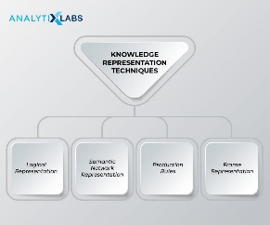

So far, we have identified how we can describe and classify the knowledge that humans possess. We also have understood what properties a proper knowledge representation will have and what use it will have in the AI’s knowledge cycle. Now the only question remains how this knowledge can be represented so that a machine can make sense of it. This leads to the discussion of exploring the various techniques or methods in representing knowledge. One has to keep in mind that there are numerous ways to achieve this, and no method is perfect and has its own disadvantages.

By and large, there are 4 main techniques out there to represent the knowledge- logical, semantic network, production rules, and frame.

**Logical Representation**

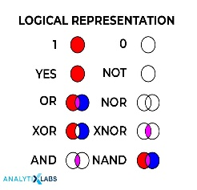

It is the most basic form of representing knowledge to machines where a well-defined syntax with proper rules is used. This syntax needs to have no ambiguity in its meaning and must deal with prepositions. Thus, this logical form of presentation acts as communication rules and is why it can be best used when representing facts to a machine. Logical Representation can be of two types-

* Propositional Logic: This type of logical representation is also known as propositional calculus or statement logic. This works in a Boolean, i.e., True or False method.
* First-order Logic: This type of logical representation is also known as the First Order Predicate Calculus Logic (FOPL). This logical representation represents the objects in quantifiers and predicates and is an advanced version of propositional logic.

If you may or may not have noticed by now, this form of representation is the basis of most of the programming languages we know of where we use semantics to convey information, and this form is highly logical. However, the downside of this method is that due to the strict nature of representation (because of being highly logical), it is tough to work with as it’s not very natural and less efficient at times.

**Semantic Networks**

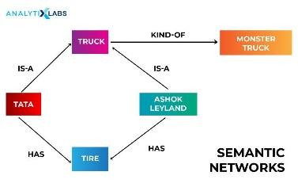

In this form, a graphical representation conveys how the objects are connected and are often used with a data network. The Semantic networks consist of node/block (the objects) and arcs/edges (the connections) that explain how the objects are connected. This form of representation is also known as an alternative to the FPOL form of representation. The relationships found in the Semantic Networks can be of two types – IS-A and instance (KIND-OF). This form of representation is more natural than logical. It is simple to understand however suffers from being computationally expensive and do not have the equivalent of quantifiers found in the logical representation.

**Production Rules**

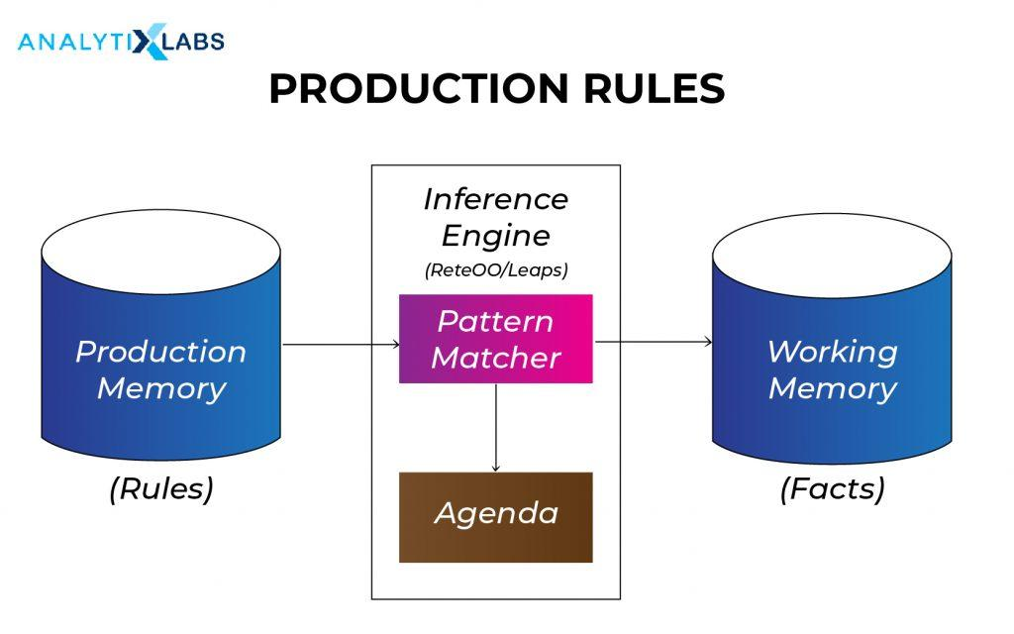

It is among the most common ways in which knowledge is represented in AI systems. In the simplest form, it can be understood as a simple if-else rule-based system and, in a way, is the combination of Propositional and FOPL logics. However, a more technical understanding of production rules can be understood by first understanding what this representation system is comprised of. This system comprises a set of production rules, rule applier, working memory, and a recognize act cycle. For every input, conditions are checked from the set of a production rule, and upon finding a suitable rule, an action is committed. This cycle of selecting the rule based on some conditions and consequently acting to solve the problem is known as a recognition and act cycle, which takes place for every input. This method has certain problems, such as the lack of gaining experience as it doesn’t store the past results and can also be inefficient as, during execution, many other rules may be active. The cost of these disadvantages can be redeemed because the rules of this system are expressed in natural language, where the rules can also be easily changed and dropped (if required).

**Frame Representation**

If this representation is to be understood at a fundamental level, then one can imagine a table having column names and values in rows and information being passed in this structure. However, the proper understanding is that it is a collection of attributes and values linked to it. This AI-specific data structure uses slots and fillers (i.e., slot values, which can be of any data type and shape). As you would have noticed, it has a similar concept to how information is stored in a typical DBMS. These slots and fillers form a structure –  a frame. The slots here have the name (attributes), and knowledge related to it is stored in the fillers. The biggest advantage of this form of representation is that due to its structure, similar data can be combined in groups as frame representation can divide the knowledge in structures and then further into sub-structures. Also, being like any typical data structure can be understood, visualized, manipulated easily, and typical concepts such as adding, removing, deleting slots can be done effortlessly.

While these are the main ways the knowledge can be represented, there are other ways, such as using scripts, an advanced technique, and a step up from frame representation.

**Approaches to knowledge representation**

The only concept we are left with now of how we can store the information in the system. Of the different ways, there are 4 main approaches to knowledge representation in artificial intelligence, viz. simple relational knowledge, inheritable knowledge, inferential knowledge, and procedural knowledge—each of these ways corresponding to a technique of representing knowledge discussed above.

* **Simple Relational Knowledge**

This is a relational method of storing facts which is among the simplest of the method. This method helps in storing facts where each fact regarding an object is providing in columns. This approach is prevalent in DBMS (database management systems).

* **Inheritable Knowledge**

Knowledge here is stored hierarchically. A well-structured hierarchy of classes is formed where data is stored, which provides the opportunity for inference. Here we can apply inheritance property, allowing us to have inheritable knowledge. This way, the relations between instance and class (aka instance relation) can be identified. Unlike Simple Relations, here, the objects are represented as nodes.

* **Inferential Knowledge**

In this method, logics are used. Being a very formal approach, facts can be retrieved with a high level of accuracy.

* **Procedural Knowledge**

This method uses programs and codes that use simple if-then rules. This is the way many programming languages such as LIST, Prolog save information. We may not use this method to represent all forms of knowledge, but domain-specific knowledge can very efficiently be stored in this manner.

***Conclusion***

The results of our analysis revealed that AI research in medicine occurs in a cascading and escalating way. While neural networks, robotics, and machine learning are the research areas with the largest number of indexed publications, they show the lowest relative interplay with other areas, whereas knowledge representation publications, having one of the smallest numbers of indexed publications, expose the highest interplay of around 45%. This supports the idea that the notion of knowledge representation might play both a historical and foundational role in the various areas, providing a common cognitive layer, a still needed context, even for domains such as machine learning , neural nets , fuzzy logic , and robotics .

***RECOMMEDATION***

***Conversely, action can substitute for reasoning. This dualism offers one way to understand the relation between traditional symbolic representations and the situated action approach, which argues that action can be linked directly to perception, without the need for intermediating symbolic representations.***

***References***

1. Jiang F, Jiang Y, Zhi H, Dong Y, Li H, Ma S et al. Artificial intelligence in healthcare: past, present and future. Stroke Vasc Neurol. 2017;2:230–43. [PMC free article] [PubMed] [Google Scholar]

2. Remenyi D.Second European Conference on Knowledge Management: Bled School of Management Bled, Slovenia, 8-9 November 2001Academic Conferences Limited2001

3. Broughton V.Essential ClassificationFacet Publishing2015

4. U.S. National Library of MedicineMedical Subject Headings - Home Page 1999.https://www.nlm.nih.gov/mesh/(accessed August 1, 2018)

5. Sperr E.PubMed by Year n.d.https://esperr.github.io/pubmed-by-year/(accessed February 2, 2019)

6. Sperr E.Website. PubVenn n.d.https://pubvenn.appspot.com/(accessed November 6, 2018)